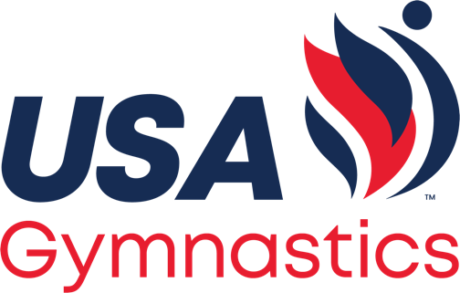
Meet Flow & Announcing
Hello and welcome to ________________ for today’s USA Gymnastics Acrobatics & Tumbling dual meet between the < announce insert team names & cities>

Sportsmanship Read
We request your cooperation by supporting the participants and officials in a positive manner. Finally, for the safety of our athletes, there is no flash photography or artificial noisemakers allowed at USA Gymnastics Acrobatics and Tumbling events. Thank you for your cooperation.
Please welcome, < Announce 1st team>
<Announce game day roster>
And now, introducing < Announce 2nd team>

<Announce game day roster>

<Same if there are more than 2 teams>

Now, we request that you please rise, and gentleman remove your hats, as we honor America with the playing of our national anthem.

Acrobatics & Tumbling combines skill sets currently practiced in artistic, acrobatic, trampoline and power tumbling, all internationally recognized and competed disciplines of gymnastics. Acrobatics & Tumbling meets are exciting, fast paced, and fan friendly. Each meet is held as a contest between 2-4 teams. Teams are evaluated in each heat by a panel of officials, receiving a score based on starting difficulty values and execution of declared skills. The team with the highest overall score is declared the winner. Awards will also be given for the overall combined score for Compulsory events and the overall combined score for Optional events.

Meet / Event 1 Intro
Each team competes identical pre-determined set of skills with a predetermined starting value of 10.0. There are four heats that include acro, pyramid, toss and tumbling. Compulsory skills are the building blocks of Acrobatics & Tumbling.

Intro Heat #1: It’s now time to begin the Compulsory Event!
- First up in the Compulsory Acro heat will be _________________
  - Participant’s Names & Numbers

- Next in the Compulsory Acro heat will be __________________
  - Participant’s Names & Numbers

Intro Heat #2: Next we have the Compulsory Pyramid Heat.
- First up in the Compulsory Pyramid heat will be ____________________
  - Participant’s Names & Numbers

- Next in the Compulsory Pyramid heat will be ____________
  - Participant’s Names & Numbers

Intro Heat #3: Our third heat of the Compulsory Event is the Toss.
- First up in the Compulsory Toss will be ______________________
  - Participant’s Names & Numbers

- Next in the Compulsory Toss will be _________________
  - Participant’s Names & Numbers

Intro Heat #4: The final heat of the compulsory event will be the tumbling heat.
- First up in the Compulsory Tumbling heat will be _____________________
  - Participant’s Names & Numbers

- Next in the Compulsory Tumbling heat will be ____________
  - Participant’s Names & Numbers

Introduce Team Event
The final event of the day will be the team event. In Team Event, teams perform individual and synchronized choreographed skills in a routine set to music. Routines are composed to showcase all skill sets that have been competed in the previous five events. This is a very fast-paced event so be sure to keep your eyes on the mat.

With a ________ Start Value, please welcome to the floor _______________

With a ________ Start Value, please welcome to the floor _______________

Announce Team Event Scores and Final Meet Results
Ladies and gentleman, we now have the final scores for today’s meet. They are as follows.
- FIRST, PLEASE ANNOUNCE THE TEAM EVENT SCORES … FOLLOWED BY THE MEET TOTALS FOR BOTH TEAMS

AWARDS
- Compulsory
- Optional
- Overall
We thank you for attending today’s meet and remind you to please drive home safely.

